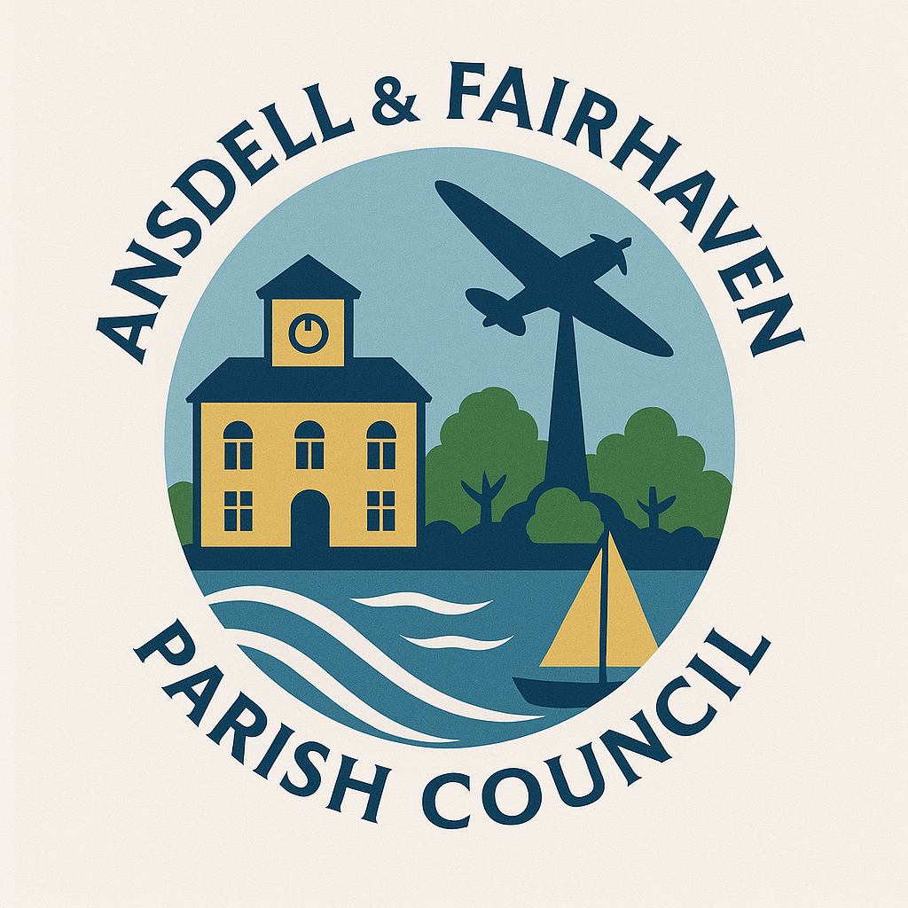
Ansdell & Fairhaven Parish Council
Agenda

You are hereby summoned to attend the meeting of the Community Engagement & Events Committee meeting of Ansdell & Fairhaven Parish Council to be held on
Monday 15th September 2025 at 6pm at the Ansdell Institute, Lytham St Annes.

Gill Flynn
Interim Clerk

1.Apologies for absence.

2.Declarations of interest and dispensation considerations.

3.Public Participation.

4.To consider the following event proposals for approval at full council:
- Raffle organisation and prizes.
- Sponsorship opportunities.
- Ideas for community involvement.
- Food glorious food event
- Christmas Ball responsibilities
- Christmas Light switch on event organisation

5.Date and time of next meetings.

Press and public are welcome.

